# Going Gym Group (GGG) by Anthony John Abril Garcia

Going gym group is a (made up) Co-Curricular Activity (CCA) group from Singapore Institute of Management (SIM). Our main goal is to instill fitness to other students while maintaining our own fitness level. We have members who are in shifts in the gym and they will give you any assistance or guidance you need.

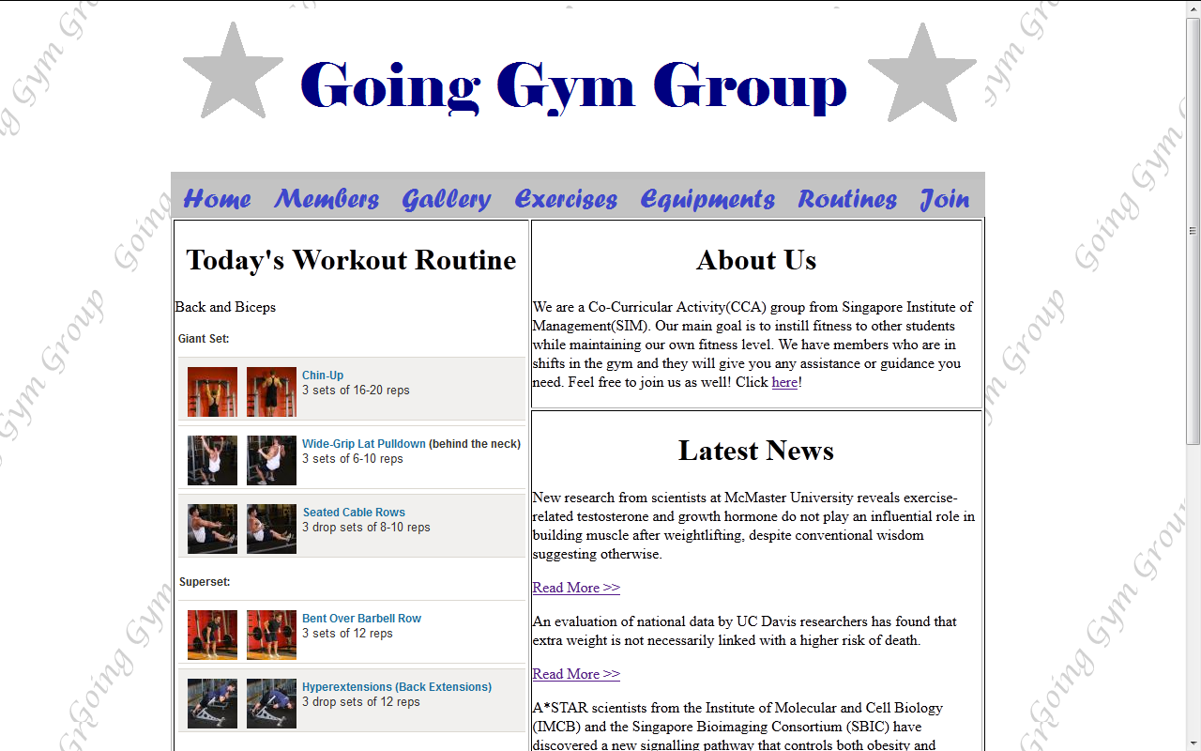

Main page of GGG (index.html)

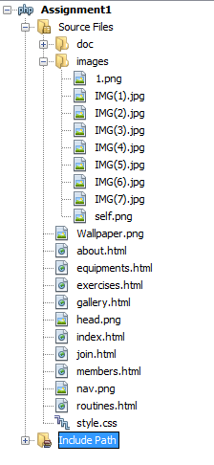

Webpage contents

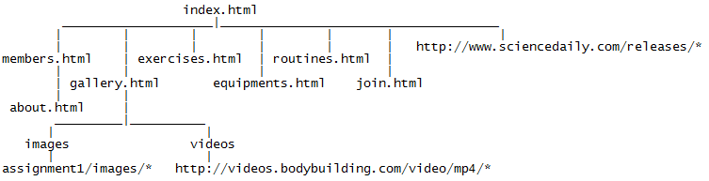

Files structure/hierarchy



Header and Navigation Bar

Navigation is done through the navigation bar. Index.html is the root file and local links and external links can be found in the hierarchy image above.

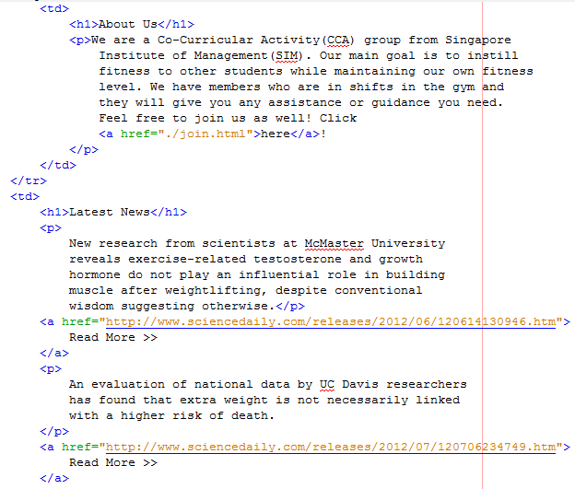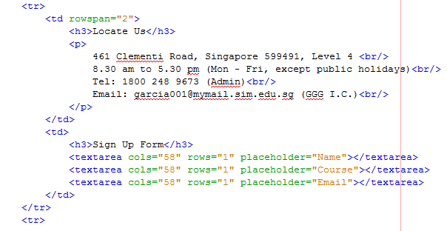

Some of the areas where h1,h3 (headers) are used. (index.html and join.html)

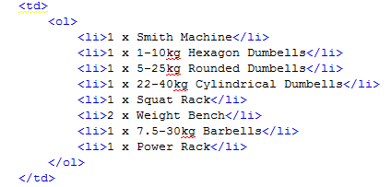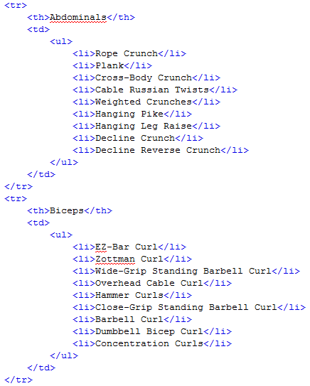

Ordered and Unordered list used in equipments.html and exercises.html respectively

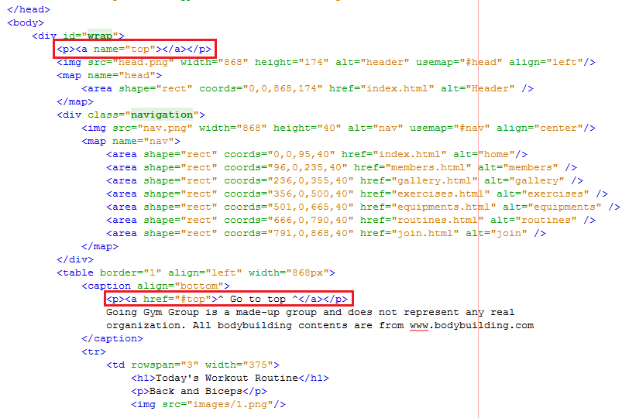

Intra page linking in index.html (go to top)

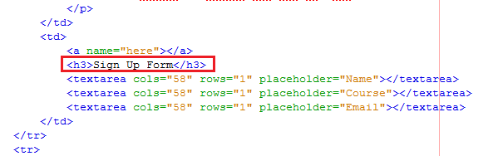

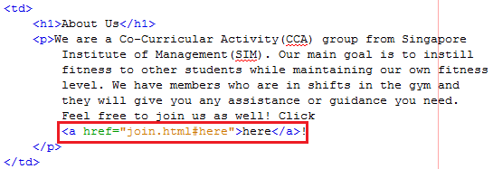

Inter page linking from index.html(below) to join the html (top)

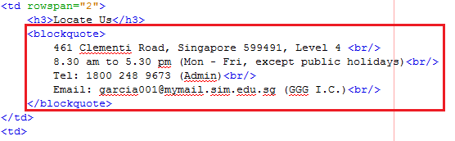

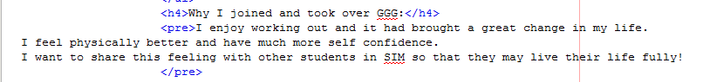

Blockquote and preformatted text used in join.html and about.html respectively

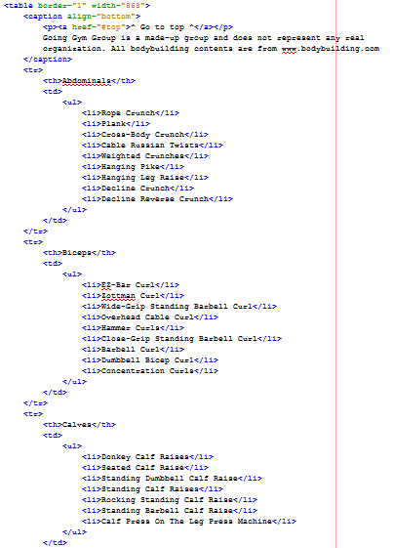

Table used in excercises.html. Other html files contain tables as well and it is used to show information in an organized manner.

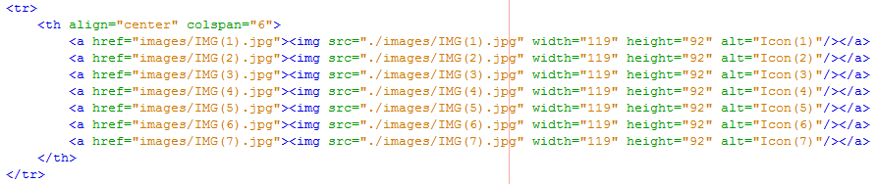

Embedded images can be found in gallery.html

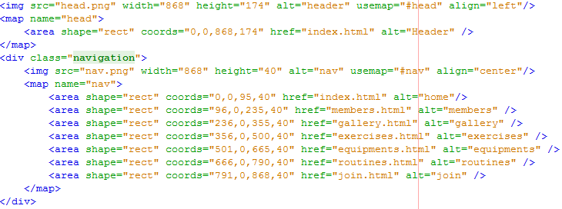

Image maps are used as navigation (bar) in my website. It is found in all html files.

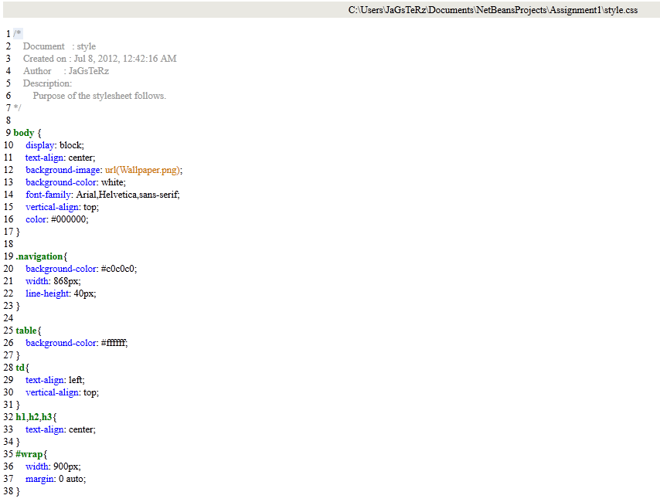

CSS style sheet, body had black fonts, white background and has background wallpaper (wallpaper.png). h1,h2,h3 texts are aligned to the center. #warp allows the webpage to be placed to the center. Navigation is set to 868px width so as to align with the header photo (head.png) which is also 868.png.

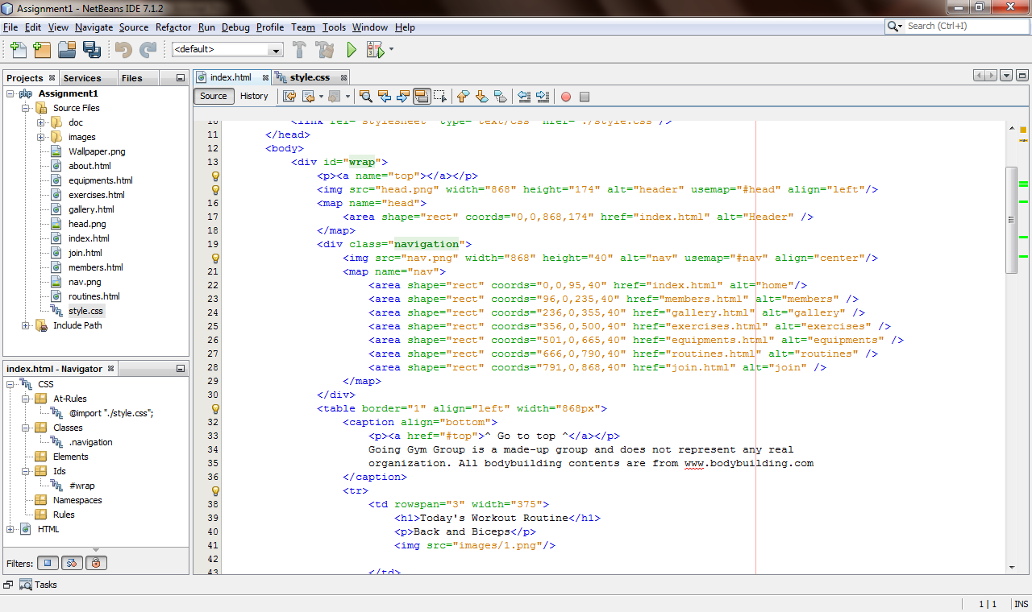

Creation of image map in index.html

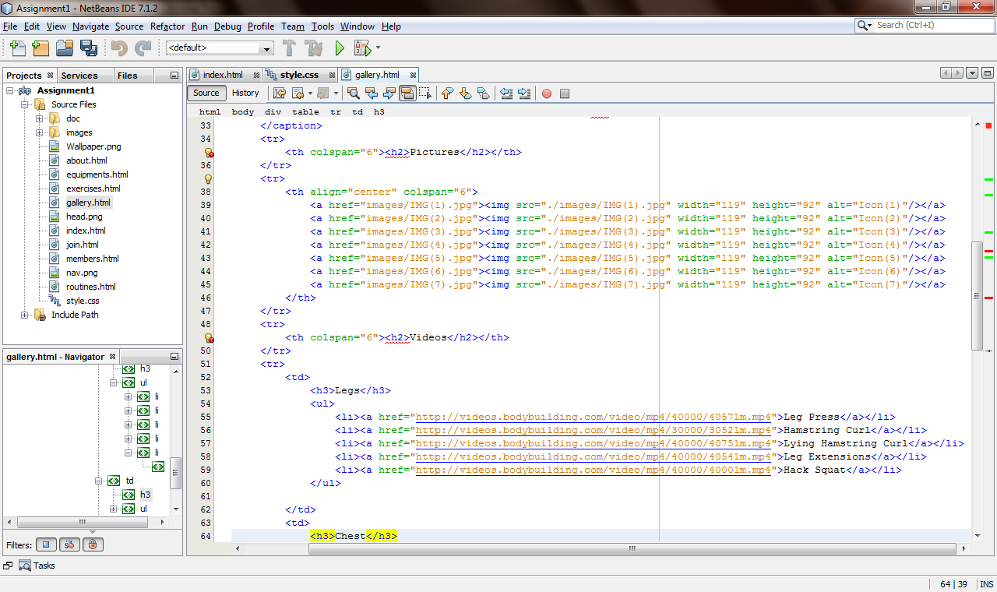

Embedding of videos and pictures in gallery.html

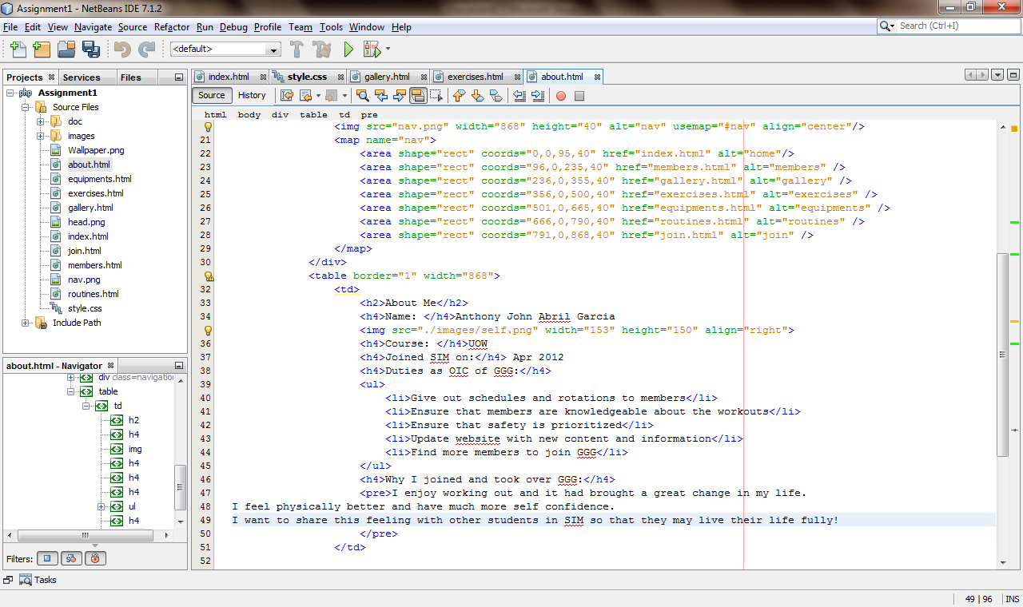

Adding preformatted text in about.html

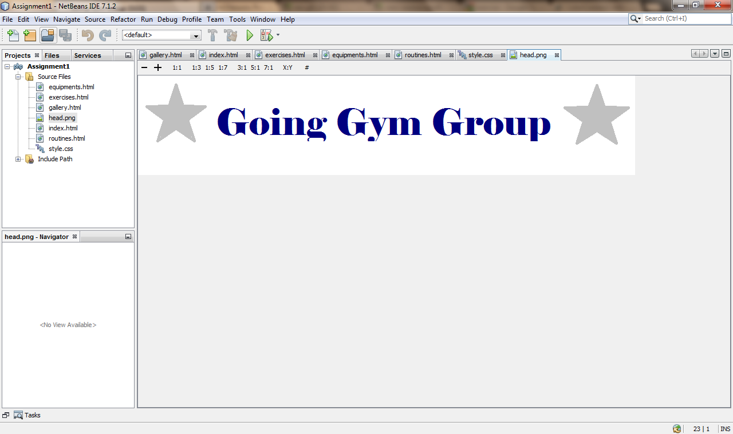

Viewing header in Netbeans

**All webpages**

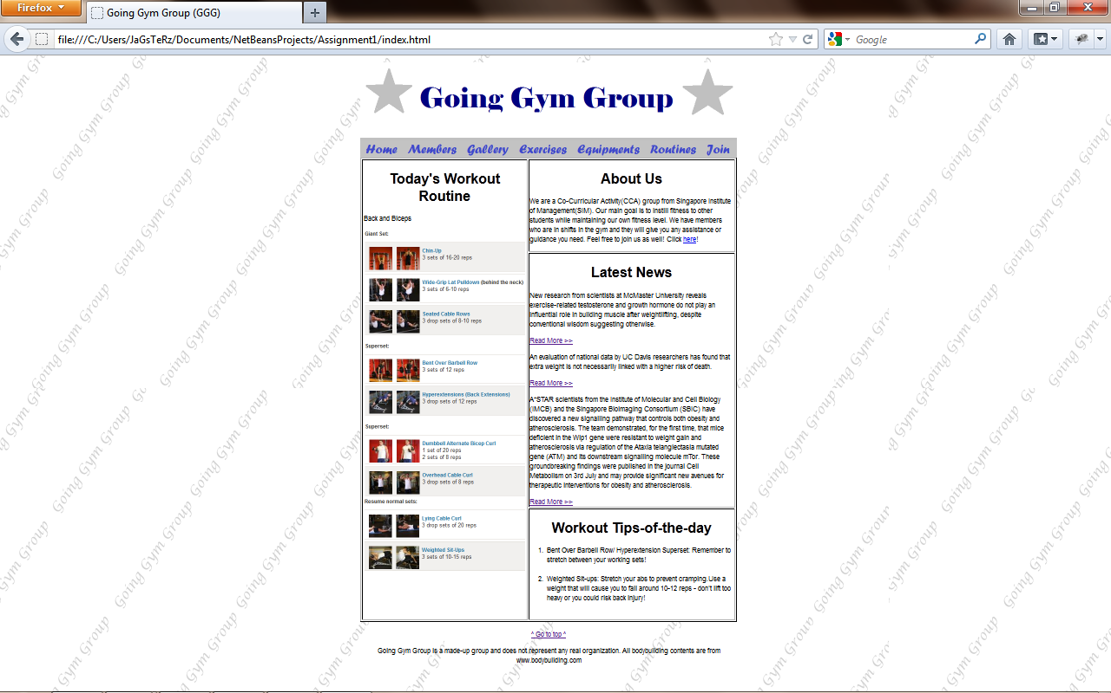

Index.html

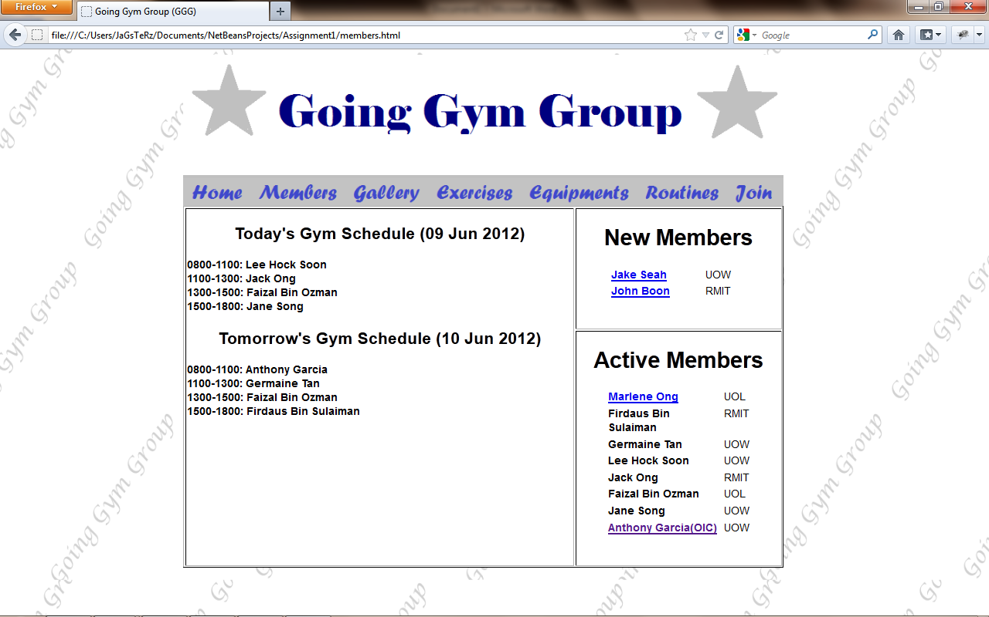

Members.html

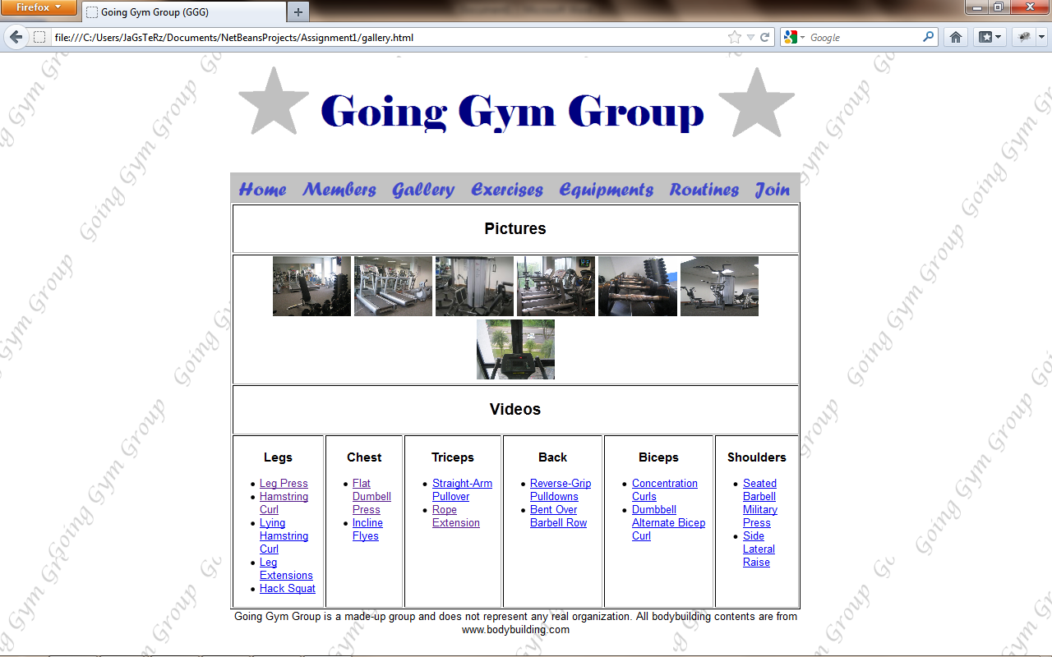

Gallery.html

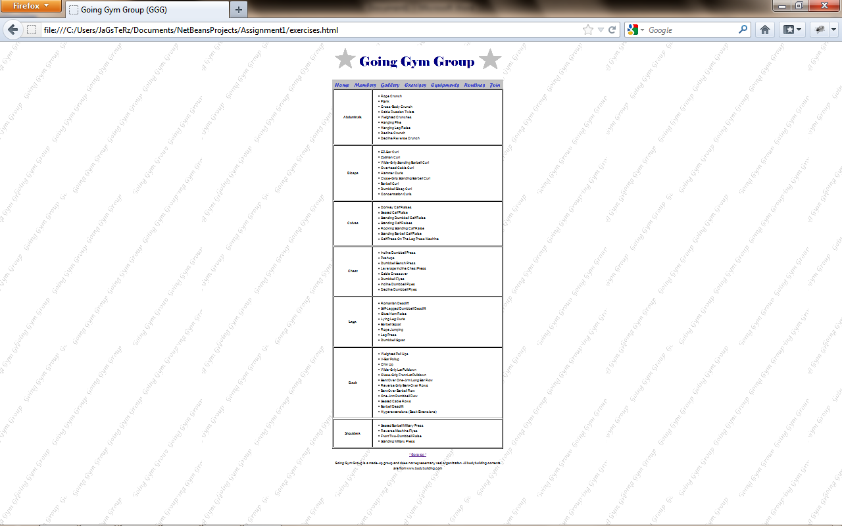

Exercises.html

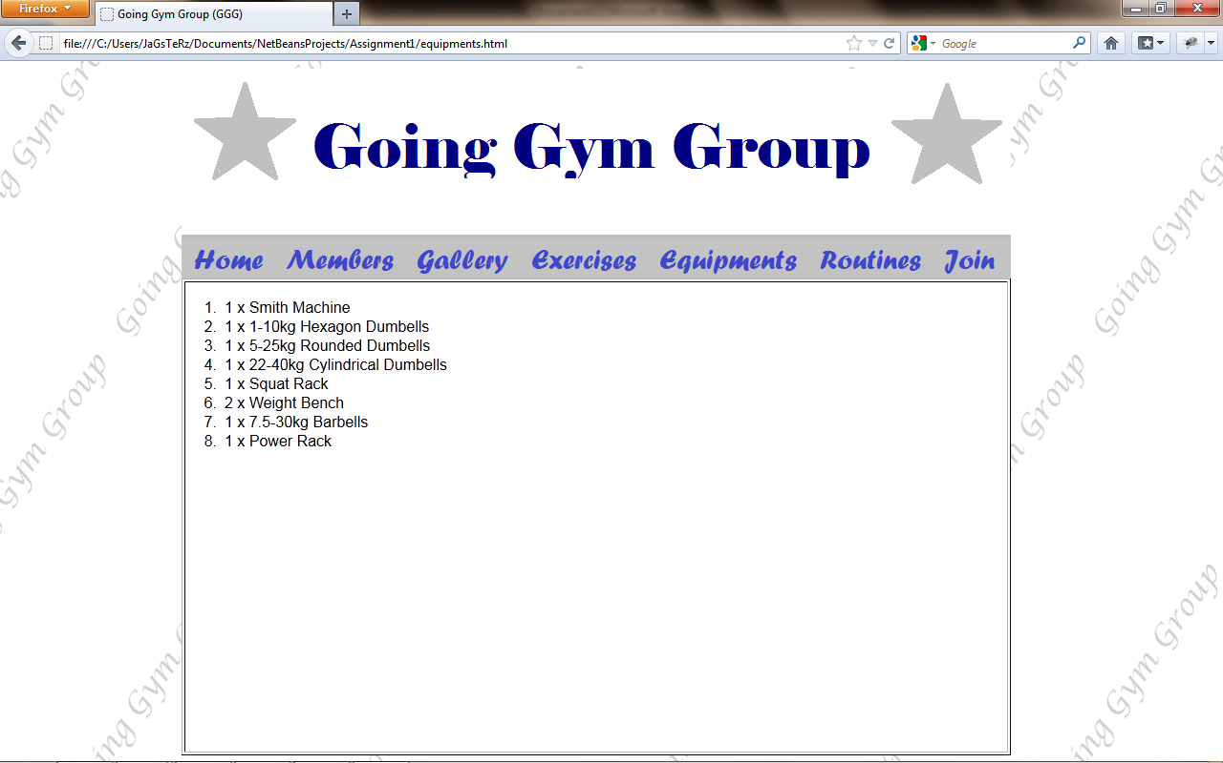

Equipments.html

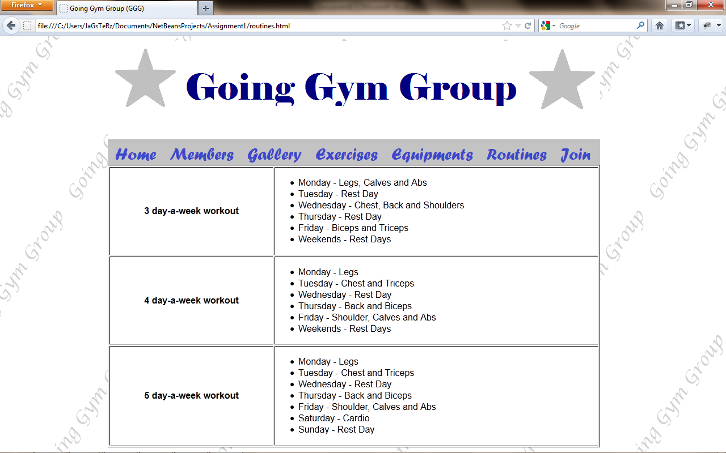

Routines.html

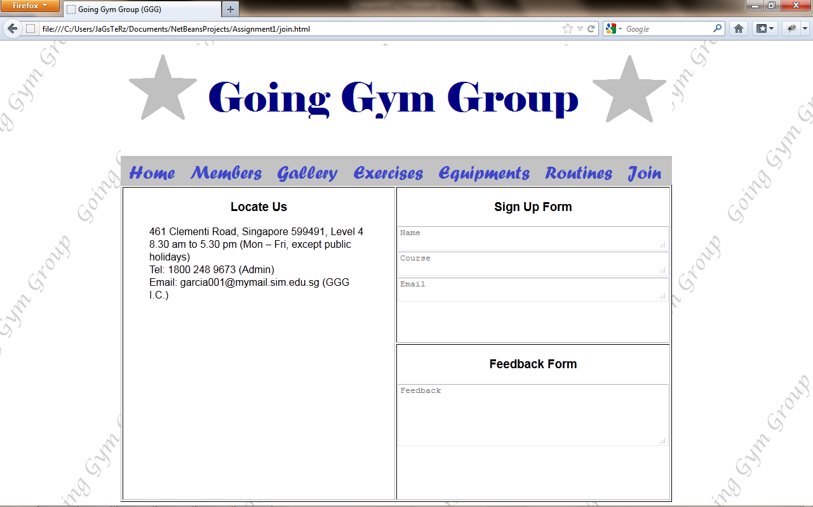

Join.html

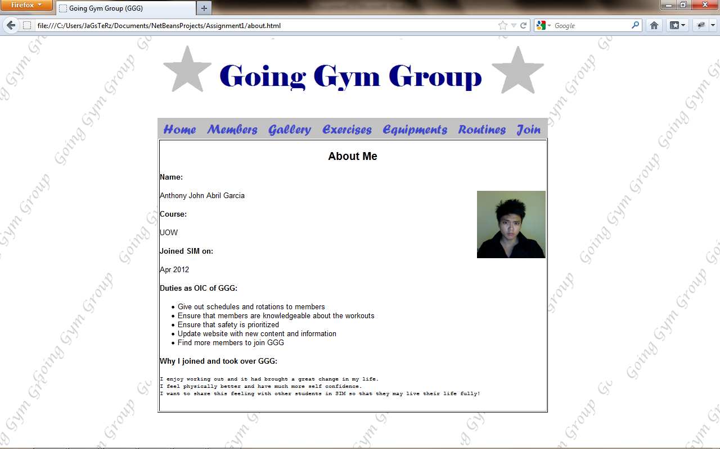

About.html